Day 5 : 22 June 2024

Component communication

If we declare any state variable of type number, string, Boolean, array or object. The scope of that state variable within that component. State variable are local to that components.

1. Using props
2. Using context api
3. Using redux

Using props

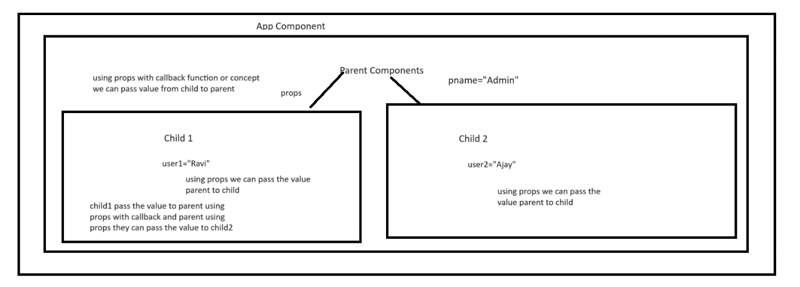

create-react-app react-component-communication

AddProduct.js

Add the data

<DisplayProduct products={products}></DisplayProduct>

<DisplayFilterProduct products={products}></DisplayProductFilter>

DisplayProduct.js

Receive products using props and display using map with table or list format.

App

Parent admin name

Props

Child1 Child2

props

Child3 Child4 Child5 Child6 Child7

Props

Child8 Child9

Context API : context API provides features which help to pass the data in component tree structure without having to pass using props explicitly.

In Context API no need to keep the track the relation level in component hierarchy.

create-react-app context-api-app

first we need to create context reference with the help of hook as createContext()

to access the value of any type from context reference we need to use another hook as useContext(ContextRefeference);

Redux : State management tools or library for Core JavaScript or JavaScript library like React JS

Redux provide container management tools features. Using redux we can make our local variable as global variable.

Redux components

1. Redux store : in Redux store provide a features to make local state variable as global variable. In Redux we can create only one store.

Redux is like database. Base upon requirement every component can access state variable from redux store using useSelector() hook in react with functional components.

1. Reducer : if store is like a database then reducer is like a table.

Reducer simple JavaScript function which takes two parameter

1st parameter initial state and 2nd parameter action. Base upon reducer is responsible to do the change on state variable part of store.

1. State : State in store are known as immutable data structure. If we want to do any changes in state variable part of redux store we need to take help of reducer. Data in tables.
2. Dispatch : Dispatch is responsible to pass the action and payload to reducer. In React with functional component we can use useDispatch() hook which help to pass event and payload

create-react-app react-with-redux

cd react-with-redux

npm install redux react-redux